
United International University
Department of CSE
Course Code: CSE 4326
Course Name: Microprocessors & Microcontrollers Laboratory
Experiment no: 1(a)
Experiment Name: Sensor Interfacing and Control with Arduino
Submitted by:
Name: Naznin Sultana Tonni(On Behalf of My Team)
Student ID’s:
- Naznin Sultana Tonni(0112330125)
- Raunak Binte Islam Faiza(0112330953)
- Talha Jubayer(0112410062)
- Rokan Uddin(0112330735)
- Atiqur Rahman Atiq(0112330317)
- Fatema Tuz Zohura Rifa(0112330722)
Section: E
Date of Submission:03/10/2026

Objective:
The objective of this experiment is to interface basic digital and analog input/output devices like a push button, a buzzer, an LDR sensor and an ultrasonic(SONAR) distance sensor with an Arduino microcontroller. The experiment covers digital input reading for button-controlled actuation (LED toggling and buzzer activation), analog light intensity sensing for automatic LED control and distance measurement using an ultrasonic sensor.

Apparatus
- Push button
- LED
- Buzzer
- LDR
- Ultrasonic (SONAR) sensor
- Resistors
- Breadboard and jumper wires
- Arduino Board
- Computer/Laptop with Arduino IDE
Theory:
1. Push Button
A push button is a simple momentary switch that connects or breaks a circuit only while it is being pressed. When interfaced with a microcontroller digital input pin, it is common practice to use a pull-down (or pull-up) resistor so the pin reads a well defined LOW (or HIGH) level when the button is not pressed, preventing the input from floating.
2. Buzzer
A buzzer is an electromechanical device that produces sound when voltage is aplied.
3. LDR (Light Dependent Resistor)
An LDR is a light-sensitive resistor whose resistance changes with light intensity high in darkness (hundreds of kohm), dropping sharply in bright light (a few hundred ohm).
4. Ultrasonic (SONAR) Sensor
An ultrasonic sensor uses sound waves to measure distance. It sends ultrasonic pulses and calculates the time taken for the echo to return.
Distance = (Speed of Sound × Time Elapsed) / 2
(divided by 2 because the measured time covers both the outward and return trip. The measured distance is displayed in meters)
Solution of the mentioned problems:
At the beginning of the experiment, I installed necessary libraries like: Arduino. Then in the proteus software I took the devices as needed (Arduino UNO, Button, Buzzer, LED, LDR Sensor, Ultrasonic Sensor).
1. Toggle an LED using a Push Button:
- Firstly I connected a push button and a LED through resistor to the Arduino. For LED I used digital pin 7 and for push button I used digital pin 2.
- Wrote an Arduino code where pressing the button toggles the LED state which is given below.
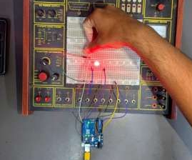

2. Turn ON a Buzzer using a Push Button:
- Now, for this task, connected the buzzer to digital pin 8 of the Arduino.
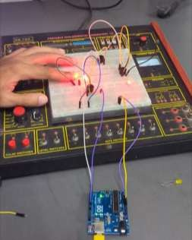
- Wrote a code to make the buzzer turn ON when the button is pressed.

3. LDR Sensor with LED:
- Made a voltage divider using the LDR and a resistor.
- Connected the LDR to an analog pin on the Arduino.
- Checked the LDR readings on the Serial Monitor.
- Set the threshold to 200.LED turns ON in low light and OFF in bright light.
An LDR is a sensor whose resistance changes with light intensity:
In bright light, its resistance decreases.In darkness, its resistance increases. This property is used in circuits to detect light levels. By connecting it in a voltage divider, the change in resistance can be converted to a changing voltage, which can then be read by a microcontroller (like Arduino) to turn devices (like LEDs) ON or OFF based on light conditions.

4. Ultrasonic Sensor for Distance Measurement:
- Connected the ultrasonic sensor to the Arduino using the trigger and echo pins.
- Wrote a program to measure the distance of any obstacle placed in front of the sensor.
- Used the pulseIn() function to measure the echo duration, which it returns in microseconds.I converted this to seconds using the formula(duration × 0.000001).
- Calculated the distance using the formula: Distance = (Speed of Sound × duration) / 2.
- Displayed the calculated distance in meters on the Serial Monitor.
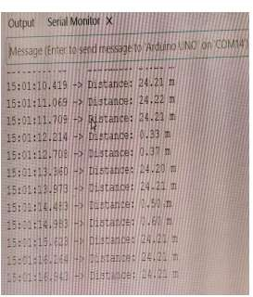
- Ran the simulation in Proteus.The sensor correctly detected obstacles and gave accurate distance readings.

An ultrasonic sensor calculates distance based on how sound waves travel and reflect. Here's how it functions:
- The trigger pin emits a short burst of high frequency sound.
- This sound wave travels outward through the air until it encounters an object and reflects back.
- The reflected wave is picked up by the echo pin.
- The sensor tracks how long it takes for this echo to return.
- Knowing the speed of sound, it converts that time into a distance value.
This is why it is used for applications like obstacle avoidance and distance sensing systems.
Program Code:

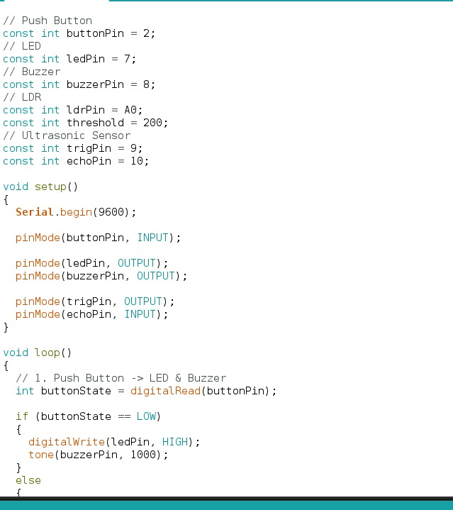

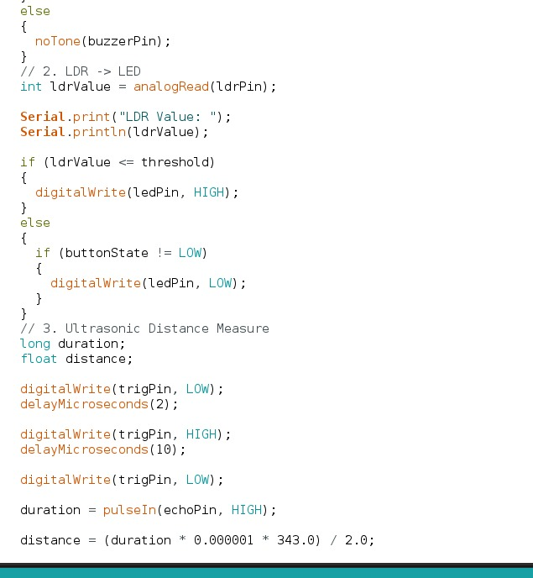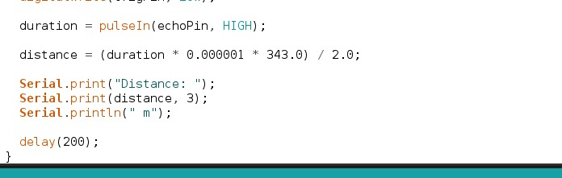

Discussion:
Through this experiment, we gained hands-on experience using push buttons to control components such as LEDs and buzzers, along with a solid understanding of how LDR and ultrasonic sensors function.
Overall, this experiment gave us practical, hands-on exposure to fundamental electronic components and sensors knowledge that directly applies to real world embedded systems and automation projects.

